This is Pele (Edson Arentes do Nascimento) before a soccer game.⬇

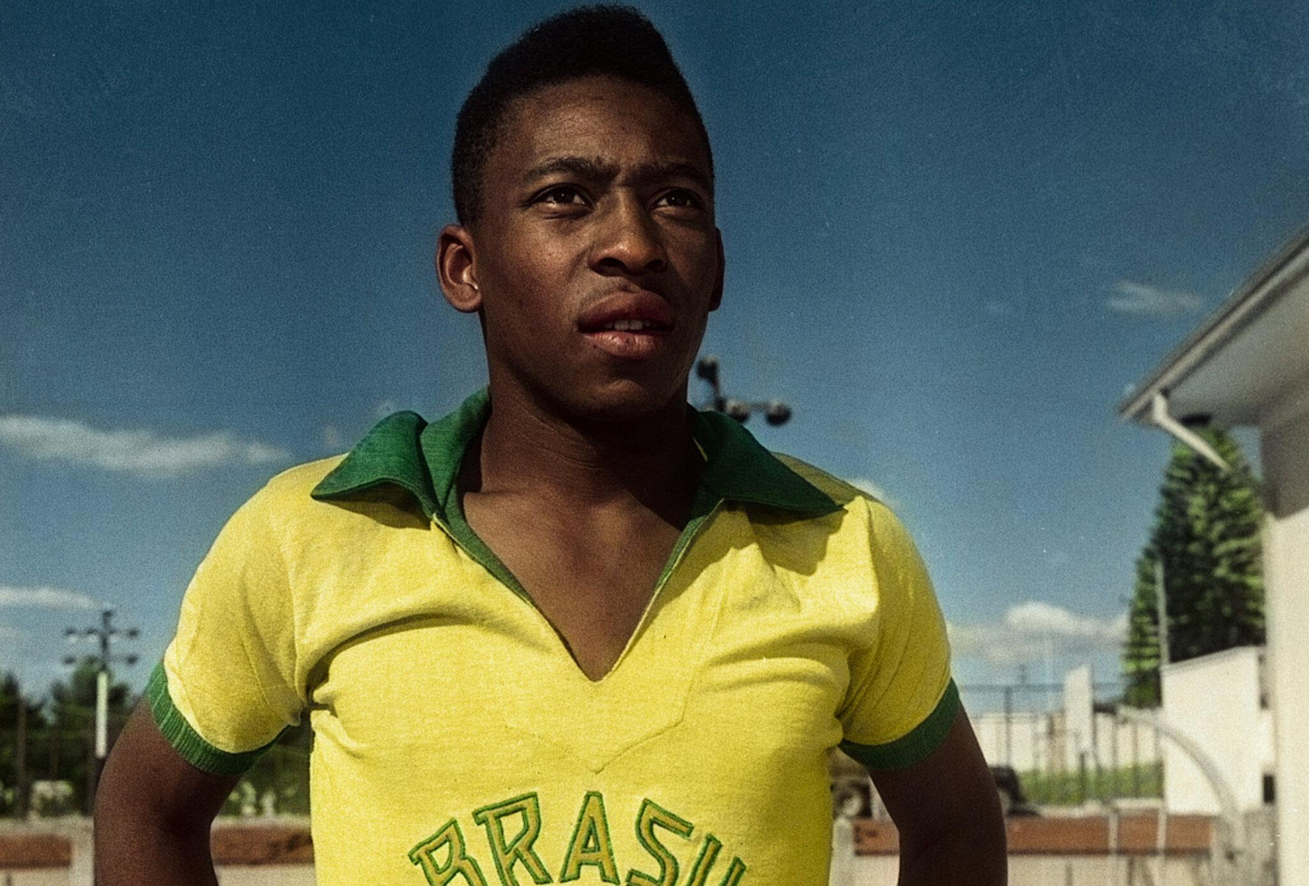

Edson Arentes do Nascimento aka Pele by Grayson Fischer

Pele was the best soccer player of all time. In my opinion, he did the best moves before they even existed. Pele was born on October 23, 1940. He started his soccer career at the age of 16. He ended his career in 1977. He had a total of 1,283 goals in his career.

**His greatest achievements**

Pele’s first ever achievement was when he won his first FIFA world cup playing for Brazil. The FIFA World Cup is the national soccer tournament where every country competes in soccer. Pele won the Ballon D’or in 2014. The Ballon D’or is one of the best soccer rewards in the world. Pele

led Brazil to three world cup championships in 1958, 1962 and 1970. During the world cup he scored 12 goals and tallied more than 1,000 goals in his first class matches.